PART-3 ASSIGNMENT-4

Create an API to collect data and you have stored this data in mongo DB Server

1. Create a folder on desktop with a file app.py to write python script
2. As we created a API to collect data from URL in the previous assignment we are going to modify the code used there in here

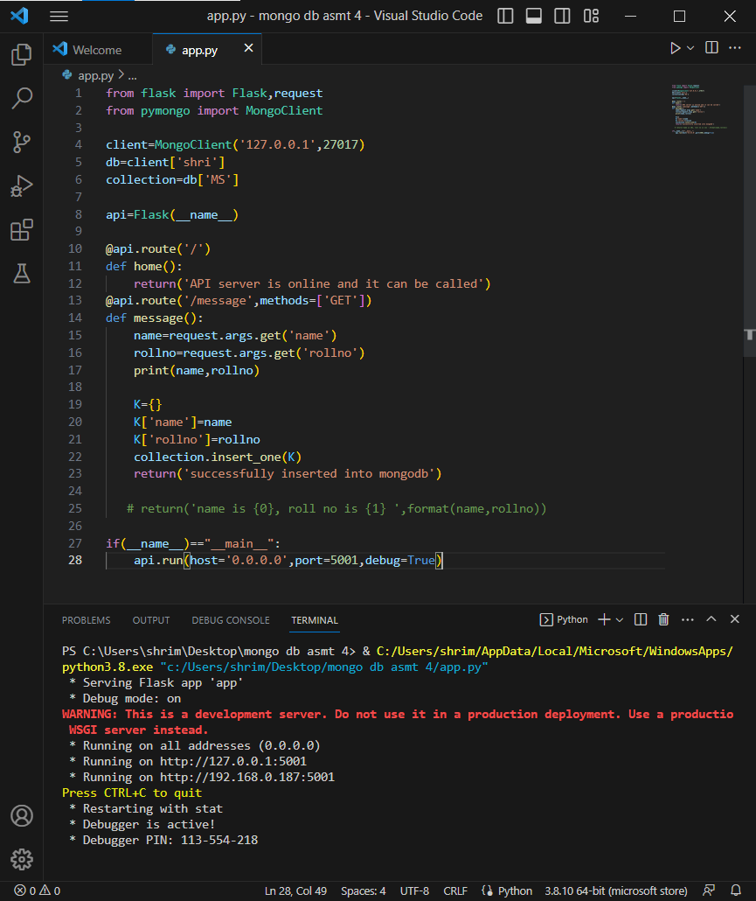

1. Run the python program and see that it is connected to the server
2. Copy the link of the server and paste it in the postman with GET method and send it.

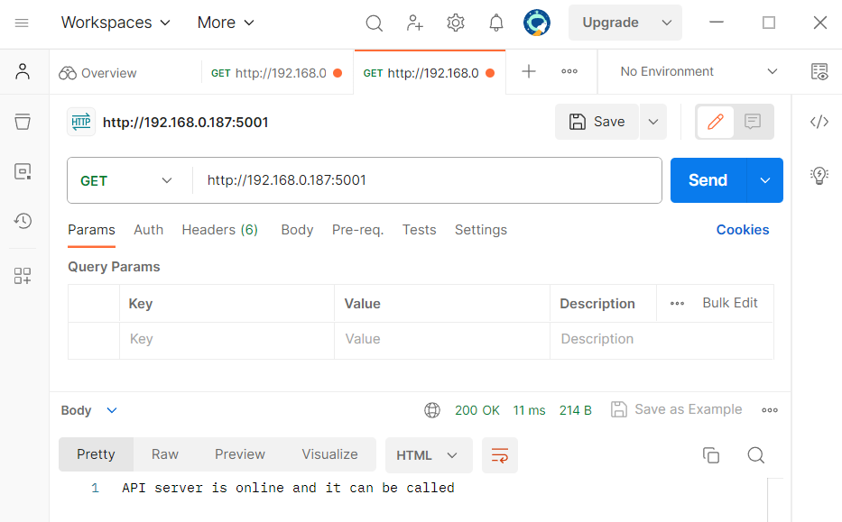

1. When key value pairs are appended at handler, we get the output and it is responded twice both at server side and API side
2. Here the data is inserted at mongo db server.

